The 2022 XR Access Symposium
June 9-10, 2022 | Virtual Event

This report was compiled by the organizers based on notes and presentations from the XR Access 2022 Symposium. If you would like to provide feedback on this report, please email info@xraccess.org.

Table of Contents
Introduction to the 2022 XR Access Symposium Report
From Principles to Practice
Event Impact
Support XR Access
Sponsors
Supporters
Acknowledgements
Organizers
Key Statistics
Setting the Stage and Keynotes
Opening Remarks: Taryn Mackenzie Williams
The Importance of the XR Access Initiative: Mike Shebanek
Keynote: Inclusive XR At Scale - The Nth Floor: Accenture
Panels
Inclusive VR Media & Entertainment
Testing and Feedback with Disabled Users
Accessible XR for Training and Collaboration
Creators with Disabilities
Research to Practice in XR Accessibility
Workstream Spotlight (bcXR): The Value of Inclusively Designed XR Workplace Tools
Deep Dives
A1: Immersive Captions and Sign Language
A2: Policy Implications for XR Accessibility
A3: Immersive Training, Learning & Inspection
A4: Non-Visual Access to Immersive Content
A5: Accessible XR Tech Transfer: From Lab to Product
A6: Designing Accessible & Inclusive XR-Enhanced Online Learning Experiences
A7: Demystifying Immersive Innovation
B1: Disability Inclusive XR Hackathon
B2: Inclusive Immersive Meetings & Collaboration
B3: Integrating Ethics into XR Systems
B4: Intersectional Equity in XR
B5: Demystifying Funding Opportunities for Inclusive XR R&D
B6: Research Networking & Collaboration Hour
Key Takeaways and Next Steps
Progress Over Perfection
Looking Ahead

Introduction to the 2022 XR Access Symposium Report

From Principles to Practice
Over four years ago, researchers and industry leaders at Cornell Tech and Yahoo! came together to organize a small gathering of academics, industry representatives, and advocates to discuss how to make emerging VR technologies accessible to people with disabilities. That group became the first XR Access Symposium, and then the XR Access Initiative.

In the past four years, XR Access has grown to hundreds of individual participants, an organizational membership program, a group of volunteer-led workstreams, and of course, our annual symposium. Much of our work has focused on establishing principles for creating and promoting inclusive XR - empowering users and creators, sharing knowledge and tools, encouraging research and innovation. Those values have served our community well.

However, a lot has changed in the XR industry, too. XR hardware is cheaper and more ubiquitous than ever. The continuing popularity of remote work and social life means that XR’s prominence in entertainment, employment, and communication has grown. XR Access, and the XR ecosystem as a whole, is at the stage where we need to do more than just state our principles: we need to put them into practice.

At the 2022 XR Access Symposium, we featured keynote speakers and panel presenters who have played key roles in putting accessibility principles into practice in the projects they create and the organizations they lead. We also spent time diving deep into XR accessibility topics across fields and industries in our expert-led deep dives. As you read this report, and the companion report “The Value of Inclusively Designed XR Workplace Tools” from our Business Case for Inclusive XR workstream, we hope you take to heart the incredible work of these leaders as you work to create a more accessible future for all.

Event Impact
This year’s XR Access Symposium featured 57 speakers, panelists, and deep dive leads. Our over 600 minutes of content reached 266 unique viewers across two days, and is available on YouTube for future viewing. Viewers represented 27 countries and 5 continents. Over 2,500 new messages were exchanged on the XR Access Slack channel on the two days of the symposium, while 9 ASL interpreters and 22 closed captioners supported the event.

Support XR Access
As a Research Consortium based at Cornell University, XR Access is largely volunteer led. Our mission is to connect and engage stakeholders across the field of XR through events, resource sharing, and other programs. However, we can’t do it alone: support from our partners is critical to help us create accessible programming, remain sustainable, and achieve our vision of inclusion.
Industry and academic/non-profit partners who share our mission and goals can help keep XR Access going by becoming a member of XR Access. Memberships are offered on an annual basis to all signatories to our Membership Agreement. Members receive benefits such as early access to research results, ability to vote on projects that receive Consortium funding, certain intellectual property, and opportunities to support Enhancement Projects in areas of mutual interest. To become a member, contact Jessie Taft, Membership & Research Coordinator, at jessie@xraccess.org.

Individuals and organizations can make a one-time or recurring monetary donation of any size to support XR Access’s work. Your donation supports XR Access’s programs, research, and overall sustainability. One-time or recurring donations can be made via the XR Access Website, and are processed by XR Access’s parent organization, Cornell University. We also welcome sustaining donations from industry partners.

Sponsors

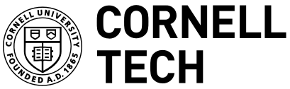

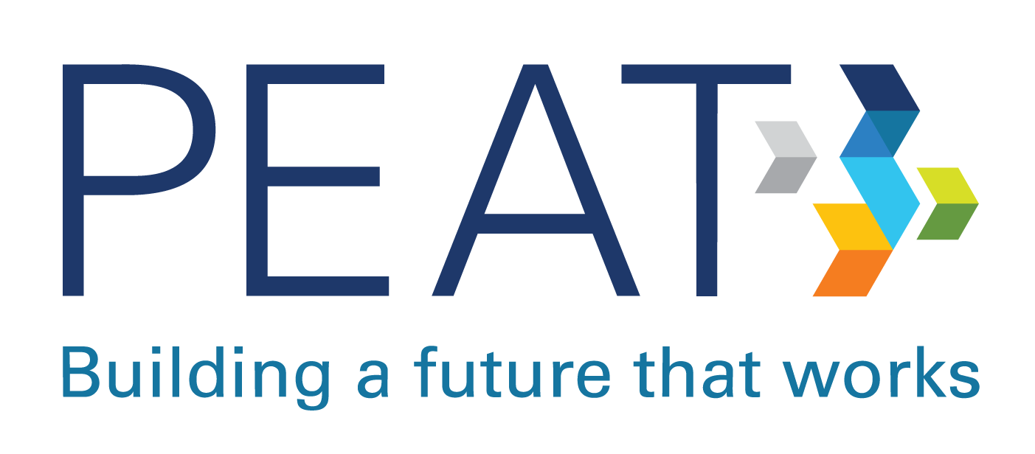

Supporters
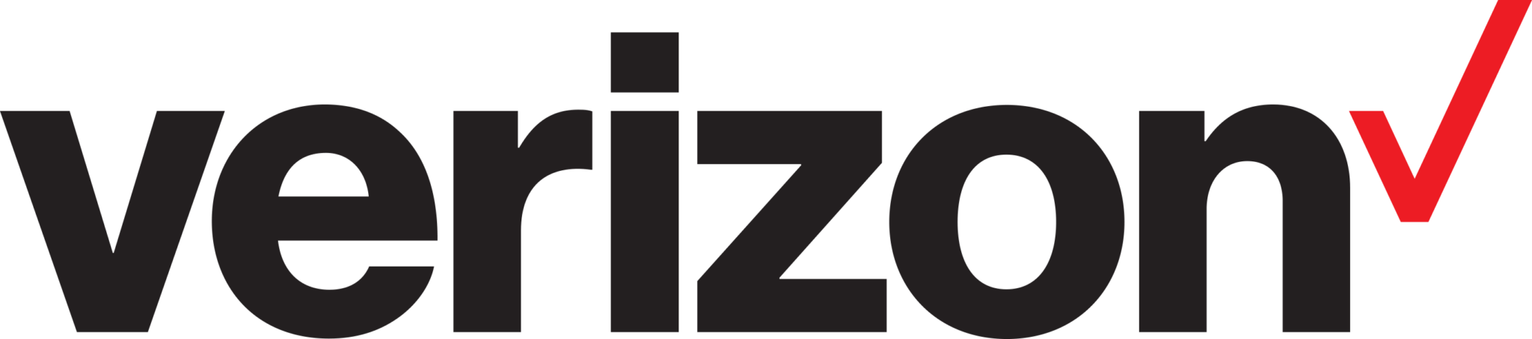

Acknowledgements
The Symposium organizers would like to acknowledge the following important contributors, without whom our event would not have been possible:
- Yahoo! Events Team for logistical support
- Interpretek for ASL interpretation services
- National Captioning Institute for captioning services

Organizers
- Dr. Shiri Azenkot, Cornell Tech, Cornell University
- Jessie G. Taft, Research Initiative Coordinator, Cornell Tech
- Larry Goldberg, formerly of Yahoo!
- Bill Curtis-Davidson, The Partnership on Employment & Accessible Technology (PEAT)
- Ashley Coffey, The Partnership on Employment & Accessible Technology (PEAT)
- Dylan Fox, XR Access Head of Community and Engagement

Setting the Stage and Keynotes
The transcript for Day 1 of the Symposium can be found at this link.

Opening Remarks: Taryn Mackenzie Williams

This year, XR Access was thrilled to host Taryn Mackenzie Williams, Assistant Secretary of Labor for Disability Employment Policy in the US Department of Labor, for opening remarks to this year’s Symposium. Williams highlighted XR Access’s achievements from the past year, including the growth of our participant community, our partnerships with the XR Association, Verizon Forward for Good Accelerator, MIT Reality Hacks, and more.

Williams also reminded us of the urgency of making accessibility a key pillar of the new world of hybrid work. “A hybrid workplace is only successful when it fully engages the skills of people with disabilities alongside everyone else.” By working together to make accessibility a priority, the XR Access community can make XR tools accessible and inclusive for all, bringing people with disabilities to the table at every step.

Resources:
- Watch Taryn Mackenzie's Opening Remarks on YouTube
- PEAT Immersive XR & Hybrid Work Toolkit

The Importance of the XR Access Initiative: Mike Shebanek

Mike Shebanek, now Head of Accessibility at Meta, believes that XR technology will have a profound impact on the ways we learn, work and play. However, he knows that accessibility isn’t a guarantee - it’s something we have to work for. At XR Access, he says, we have the potential to get XR accessibility right from the beginning - to make new tech that’s “born accessible”.

As a speaker at our very first symposium in 2019, Mike has seen XR Access grow into a thriving community with hundreds of participants all over the globe. He notes that we’re not just a think tank - our members build new projects, write code, research new ideas, and build bridges between academia, industry, government, and the disability community. At Meta, Mike doesn’t just help make technology like the Quest headset accessible, he’s also contributing to research efforts by supporting Dr. Shiri Azenkot’s research work on making social interactions in VR more accessible to people with visual impairments.

Resources:
- Watch The Importance of XR Access on YouTube
- Meta accessibility

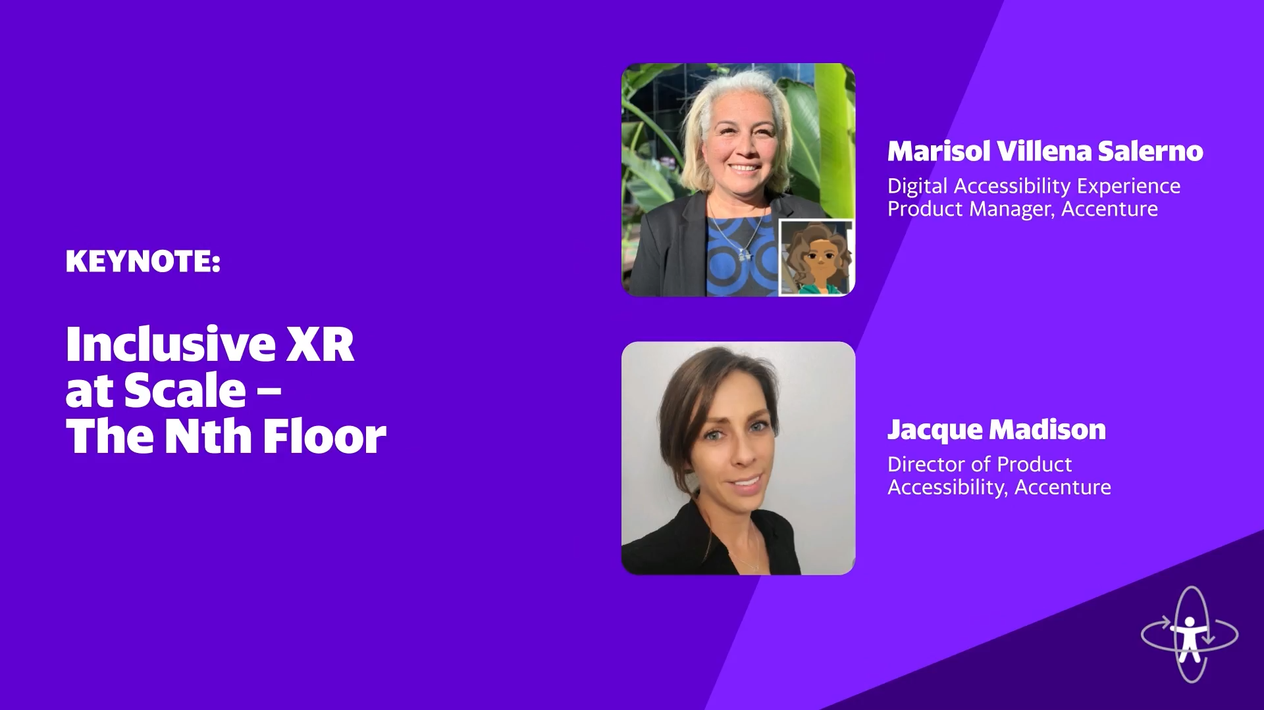
Keynote: Inclusive XR At Scale - The Nth Floor: Accenture
Jacque Madison, Accenture
Marisol Villena Salerno, Accenture

The keynote of the 2022 XR Access Symposium began with an introduction by Bill Curtis-Davidson of PEAT and Elizabeth Hyman of XRA. They showcases the meteoric rise of XR for use in enterprise learning and development, with 81% of HR professionals considering adopting XR for learning and development. They also highlighted the Inclusive XR in the Workplace white paper and Inclusive XR & Hybrid Work Toolkit before passing the mic to Jacque Madison and Marisol Villena Salerno of Accenture.

For this year’s keynote, we are honored to welcome Jacque and Marisol to discuss their experiences with creating, deploying, and improving Accenture’s enterprise metaverse. Accenture’s work on ensuring that its enterprise metaverse is inclusive to all of its employees aligns with the theme of this year’s symposium, putting principles into practice. It’s also a perfect example of the innovative solutions that are possible when a company commits to inclusion at scale from ground up.

Jacque began the keynote by describing Accenture’s goals of including all of its employees in a metaverse that’s not only engaging, delightful, inclusive, and easy to use, but that pushes the boundaries of what’s possible in a work environment. Marisol described the process of how the company achieves these goals through inclusive design. Her team locates and defines accessibility and inclusion barriers within the product, connects with employee research groups to get feedback, and iterates with users, partners, and vendors to remove barriers and create experiences that are usable by all.

The keynote concluded with a reminder that accessible design of workplace XR technologies not only improves experiences for employees with disabilities, but for all employees. Using principles of inclusive design, Accenture was able to create inclusive change not only within their own enterprise metaverse, but with their vendors and contractors as well. Accenture’s experiences remind us that these changes are possible for any company that’s willing to start from the beginning and commit to accessibility from the ground up.

Resources
- Watch The Nth Floor on YouTube
- Whitepaper on XR in the Workplace

Panels

Inclusive VR Media & Entertainment
Erik Lohr, Ryot Studios
Danny Woodburn, The Mulberry Tree Group
Athena Demos, Big Rock Creative (BRCvr)
Delbert Whetter, Exodus Film Group & RespectAbility
Damián Turkieh, Realidad 360 Argentina

The Symposium’s first panel of the day brought together leaders in accessibility and media to discuss the future of accessible XR in the entertainment industry. The panel was moderated by Erik Lohr of Ryot Studios, and featured Danny Woodburn, Athena Demos, Delbert Whetter, and Damián Turkieh. The conversation touched on representation in the film and XR industries, examples of accessible experiences, and what the future might hold for XR entertainment.

First, panelists noted that while diversity and inclusion have been major discussion points in the film and television industries for several years, disability and accessibility has been left out of the conversation. They emphasized that while XR entertainment is still emerging, centering people with disabilities should be a priority, whether that’s in front of or behind the camera - for example, hiring actors with disabilities to play both disabled and non-disabled characters. “It’s a labor equality issue”, says producer Delbert Whetter.

Another common theme was the ways in which XR can exacerbate the lack of inclusion in film and TV. While it’s one thing to not be able to see ourselves represented in film, XR invites us to inhabit avatars and virtual spaces that don’t represent us and aren’t meant to accommodate us. VR filmmaker Damian Turkieh’s series 4 Feet High is one example of a project that’s meant to fight this lack of representation - not only is the series’s main character a wheelchair user, but the immersive story invites us to see the world from her perspective.

Despite continuing challenges, the panelists are excited for the future of XR entertainment. They cite new ideas like haptic feedback, 3D printed devices, accessible casting processes, distributed filmmaking, and multilingual live captioning in virtual spaces as areas for exploration that can help make the future of immersive media more accessible.

Resources:
- Inclusive VR Media & Entertainment on YouTube

Testing and Feedback with Disabled Users
Christine Hemphill, Open Inclusion
Randy Huzinec, University of Pittsburgh Medical Center
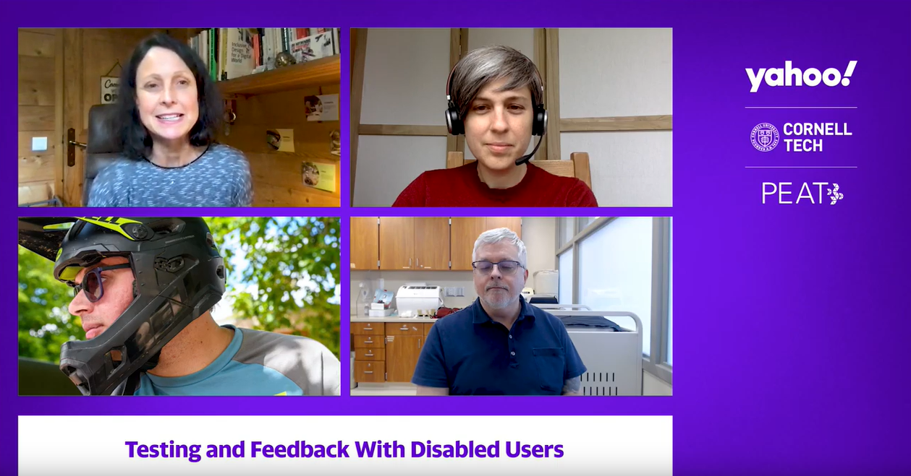
Kate Mesh, Open Inclusion
Jamie Knight, Independent
Lynn Cox, Open Inclusion

The Symposium’s second panel was moderated by Christine Hemphill and featured inclusion and XR experts Randy Huzinec, Kate Mesh, Jamie Knight, and Lynn Cox. Panelists discussed the ways that inaccessible XR poses barriers to users, how they involve people with disabilities in their research and other work practices, and how other XR designers, developers, and researchers can benefit from early input from users with disabilities.

The panel emphasized a few key items for XR creators to consider. First, it’s important to recognize that while re-creating “real life” in XR is a goal for many, we need to work hard to make sure that the barriers present in real life aren’t replicated in XR spaces. “That’s the thing about VR and XR: if we’re just replicating the barriers that we’ve created in real life, we are letting people down,” says Jamie Knight.

Second, when designing with people with disabilities, out of the box solutions don’t always work - some default features of XR technologies can even pose barriers that make even deeper accessibility challenges difficult to uncover. Solving initial barriers can open the doorways to learning more about the design assumptions that lead to exclusion, and can help us create more accessible technologies.

Finally, panelists emphasized that good accessibility testing takes effort, and needs to start at the beginning of the product design process. Learning early on about barriers and assumptions can not only make final products more accessible, but can save time and money later on. “It will not cost a fortune because you thought about it from the beginning,” says Lynn Cox of Open Inclusion.

Resources:
- Watch Testing and Feedback with Disabled Users on YouTube

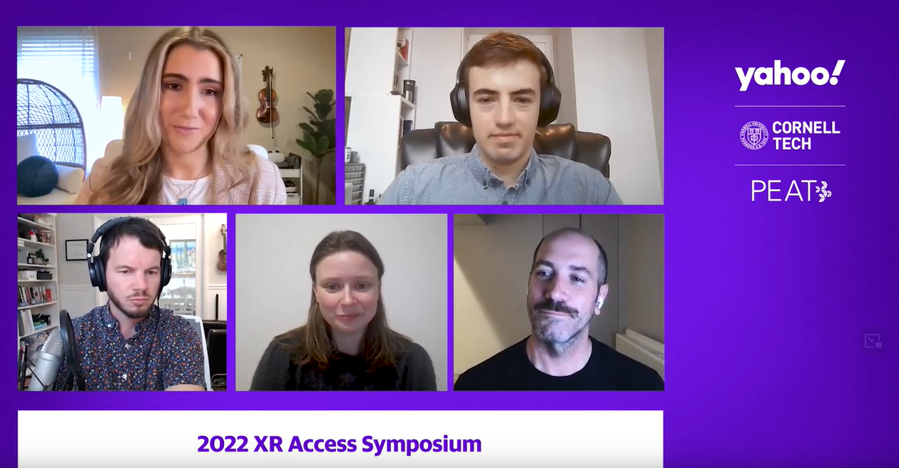
Accessible XR for Training and Collaboration
Ashley Coffey, PEAT
Mark Steelman, Transfr
Tim Stutts, XR Design Leader
Elgin-Skye McLaren, Mozilla Hubs
Thomas Logan, Equal Entry

The third panel of the 2022 Symposium was moderated by PEAT Emerging Technology Consultant Ashley Coffey, and featured Tim Stutts, Mark Steelman, Elgin-Skye McLaren, and Thomas Logan, all XR creators and technologists with deep expertise in using XR in teaching, learning, and collaboration. These contexts touch on workplace and social technologies, which come with their own unique challenges and opportunities.

Panelists discussed their experiences with making their own XR tools accessible, especially highlighting the need to involve people with disabilities in the design process at an early stage, no matter the cost. “I cannot emphasize enough the importance of going out and using your product with the community and seeing how people are interacting with it,” says Elgin-Skye McLaren.

When it comes to workplace technologies, panelists also noted the need to create change within the technology procurement process. Policies that encourage companies to procure accessible technologies not only create more accessible workplaces, they encourage innovation and allow product designers to see accessibility as a value-add. “The law is set up, for procurement, to say you are supposed to procure the most accessible product”, says Thomas Logan. “If your product is more accessible, that should be a sales point for you.”

Other challenges and opportunities covered in this panel include the need to make platforms customizable and cross-platform compatible. Providing flexibility to users with different or intersecting needs is key to creating social and work experiences that suit the needs of the greatest number of people.

Resources:
- Watch Accessible XR for Training and Collaboration on YouTube
- The Value of Inclusively Designed XR Workplace Tools

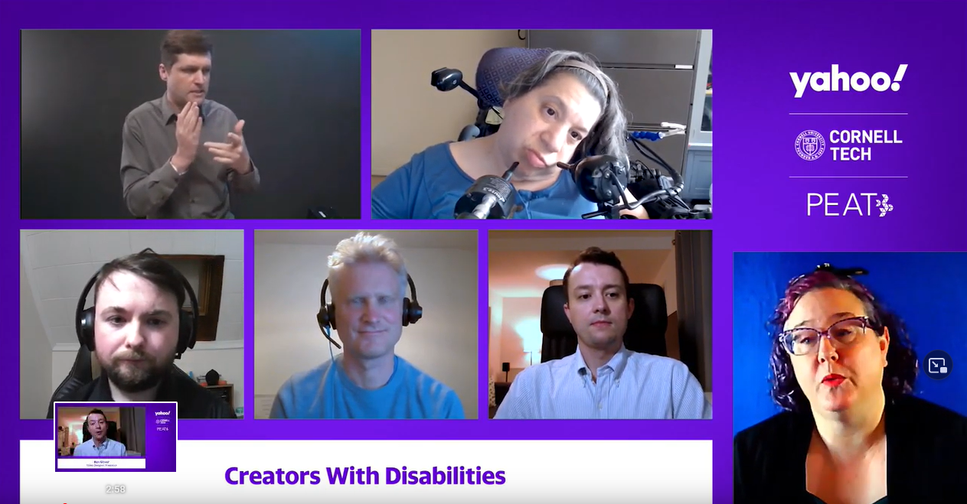
Creators with Disabilities
Myles de Bastion, Cymaspace
Chris Hainsworth, BlindBurners
Adriana Mallozzi, Puffin Innovations
Ross Kilpatrick, VR Hive
Ben Glover, Independent

The fourth Symposium panel of the day features people with disabilities who are leaders in the areas of technology and creativity. Moderator Myles de Bastion and panelists Chris Hainsworth, Adriana Mallozzi, Ross Kilpatrick, and Ben Glover are all founders, project directors, and lead developers at companies and on projects that push creative and technological boundaries and bring new ideas of accessibility to audiences everywhere.

Panelists highlighted many challenges and opportunities that come with being leaders in the XR space. One of these is the ability to ensure that the needs of diverse individuals are met when it comes to emerging technologies. However, as Ross Kilpatrick says, one of the challenges ahead is that “we really get too bogged down meeting so many needs that we reach none.” He and other panelists noted the need to create the ability to personalize accessibility features to embrace users with intersecting disabilities or other use needs.

Many panelists are also excited about the educational and economic opportunities that come from people with disabilities leading technology development. “What excites me most is the creative and economic impact that will flow from disabled authorship,” said Chris Hainsworth. When it comes to making business and creative decisions, Ben Glover concurred, saying “I’m excited to see people with disabilities who are now involved at the heart of these decisions.”

Other common themes that arose during this panel include the challenges sound convincing tech companies and non-disabled creators to spend the time, money, and energy to make changes that reduce accessibility barriers for people with disabilities. Designing an XR product with accessibility in mind from the beginning is easier said than done, and - as Adriana Mallozzi notes - bringing “disability and access to the forefront is a challenge all around”.

Resources:
- Watch Creators with Disabilities on YouTube

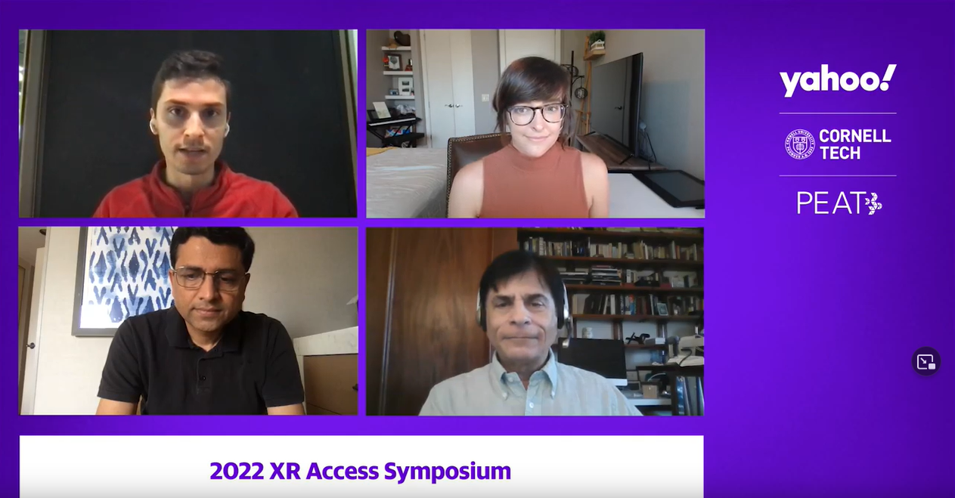
Research to Practice in XR Accessibility
Ricardo Gonzalez, Cornell Tech
Haley Adams, Vanderbilt University
Raja Kushalnagar, Gallaudet University
Steven Feiner, Columbia University

The final panel of Symposium Day 1 featured academic researchers working in the area of XR and accessibility. Moderator Ricardo Gonzalez and panelists Haley Adams, Raja Kushalnagar, and Steven Feiner all have experience designing accessible technology and working with people with disabilities on research projects. Each researcher began by presenting key findings from their own research. For example, Haley Adams’s projects on creating low vision simulators that help designers without low vision understand others’ experiences taught her that while simulators can help, there’s no substitute for designing technologies along with disabled users.

Collaboration between academia and industry is key for XR Access, and the panelists all had suggestions for building connections that help make technology accessible. For example, multiple panelists highlighted the importance of informal communication between researchers, industry leaders, and users on different social media platforms. There, research findings can be shared accessibly, and people with disabilities can find opportunities to give feedback to industry prototypes.

Panelists also noted another key area that can help advance accessibility research: access to hardware and software. Being able to build new applications on top of prototype hardware can help researchers explore what’s possible in a space. Similarly, operating system-level access to development and hardware tools - something often only a manufacturer can provide - can help users build new prototypes that are extensible and usable across platforms, which is key in creating tech that’s accessible from day one.

Resources:
- Watch Research to Practice in XR Accessibility on YouTube

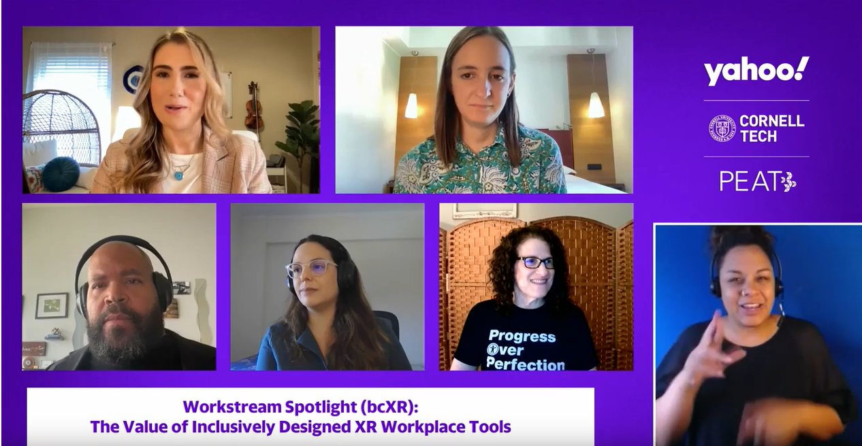
Workstream Spotlight (bcXR): The Value of Inclusively Designed XR Workplace Tools
Introduction by Alexa Huth, PEAT
Ashley Coffey, PEAT
Maddalena Crosti, Crosti Co
Stewart Tucker Lundy, actor/advocate
Joana Alemão, Moonbeam
Meryl Evans, Equal Entry

Day 2 of the symposium kicked off with a presentation by members of XR Access’s Business Cases for Inclusive XR (bcXR) workstream. The panel was introduced by Alexa Huth and moderated by Ashley Coffey, with panelists Maddy Crosti, Stewart Tucker Lundy, Joana Alemao, and Meryl Evans. The group presented the results of bcXR’s research project on inclusive XR in the workplace.

The bcXR workstream has a clear vision: a future where new and emerging technologies are accessible to the workforce by design. XR, which is increasingly used for training, socializing, upskilling, and communicating in the workplace, can be a way to open new opportunities for employment. But to fulfill its potential, it must be born accessible.

In their project, the bcXR team explored current social VR products available on the market, evaluating their available accessibility features. The workstream’s report describes their findings on the current state of accessible workplace XR, and their recommendations for improving accessibility.

This project isn’t just a useful research report for the whole XR community - it’s an example of the deep, impactful work that XR Access’s workstreams do. They’re also a full-community effort, with XR Access individual participants volunteering their time, and institutional members providing financial support and guidance. To learn more about how your institution can get involved in XR Access, please visit xraccess.org/memberships.

Resources:
- Watch The Value of Inclusively Designed XR Workplace Tools on YouTube
- Report: The Value of Inclusively Designed XR Workplace Tools

Deep Dives

A1: Immersive Captions and Sign Language
Moderator: Brenden Gilbert (Meta)
The Immersive Captions and Sign Language deep dive explored the work of the W3C Immersive Captions Community Group and how XR could be made more accessible to d/Deaf people and other users of captions and sign language.
Governments can be more engaged in regulating the usage of accessibility features, both on the web and XR. They could also serve as a role model for private organizations by offering more jobs with proper accommodation to the disabled community, and put pressure on content creators to make their products “born accessible.”
As for captions themselves, some best practices include indicating audio location and speaker identity, offering users preferences over how and where their captions appear, and considering ways of communicating emotions and other nonverbal information.
Resources:
- Watch A1: Immersive Captions and Sign Language on YouTube
- Transcript for A1
- W3C Immersive Captions Community Group
- Immersive Captions Community Group - Best Practices for 360° Captions

A2: Policy Implications for XR Accessibility
Moderators: Corinne Weible (PEAT), Joan O’Hara (XRA), John Soroushian (Bipartisan Policy Center)

The Policy Implications for XR Accessibility deep dive explored what recent findings and research reports mean for the XR industry. The six priorities are privacy, security, economic issues, access and adoption, equity and inclusion, and safety.

To address these and get buy-in, it’s important to frame accessibility message carefully as a business investment and benefit to all users. Elected officials often pay special attention to local job and employment opportunities and access to education or healthcare; showcasing how accessible XR supports these could be very effective. The government was a major funder of closed captioning, and makes a great investor for new accessibility technologies.

It’s also important to develop multi-stakeholder approaches when designing frameworks and best practices for XR. Consider people who are multiply marginalized, e.g. LGBTQ disabled people, as well as such different research applications as autonomous vehicles and training for people with autism spectrum disorder.

Resources:
- Watch A2: Policy Implications for XR Accessibility on YouTube
- Transcript for A2
- Bipartisan Policy Center report: Thinking Ahead About XR: Charting a Course for Virtual, Augmented and Mixed Reality

A3: Immersive Training, Learning & Inspection
Moderators: Mark Steelman (Transfr), Tim Stutts (Interactive Experiences at Cognixion)

The Immersive Training, Learning, and Inspection deep dive discussed ways to incorporate inclusive and accessible design approaches in immersive instructional applications for vocational occupations and hands-on skills.

Tim reviewed the UI and UX of the Vuforia AR applications he worked on at PTC, including inputs and sensory feedback opportunities, the Vuforia Capture and Vantage apps, and the differences between AR platforms. Menu design, AR keyboard input, and 3D navigation are important avenues for considering accessibility.

Developers can and should be aiming for better accessibility features such as controller and input tutorials, input flexibility, captions, accessibility object models for enabling screen reader compatibility, pausing and playing, skipping and rewinding, and virtual locomotion. Including these, and documenting them using a VPAT, can greatly boost your product’s performance and competitiveness.

For the future, consider:
- How can we tailor training and learning experiences to a user’s learning ability?
- How will XR enhancements of vocational jobs improve the hiring process?
- How can XR training can prolong human involvement in increasingly automated fields?
Resources:
- Watch A3: Immersive Training, Learning & Inspection on YouTube
- Transcript for A3

A4: Non-Visual Access to Immersive Content
Moderators: Stephanie Montgomery (XRA), Thomas Logan (Equal Entry), Roland Dubois (Shop-Ware, School of the Visual Arts)

The Non-Visual Access to Immersive Content deep dive explored non-visual ways to make immersive content accessible to those who are blind or who have limited vision.

Thomas Logan presented his work in developing VR environments with interfaces for the blind. His work focused in 3 key areas: Object description, Environments, and Avatars. He shared the scenarios that he was using to frame these challenges.
Key concepts that can improve accessibility for low-vision users:
- Good alternate text for all objects, with added detail for avatar selection.
- Object attributes such as size, texture, volume, place, distance, and interaction behavior defined via text.
- Robust audio cues to indicate user status and interactions, leveraging the knowledge base from audio-only games.

Resources:
- Watch A4: Non-Visual Access to Immersive Content on YouTube
- Transcript for A4
- Building a More Accessible Social Virtual Reality World - Thomas Logan

A5: Accessible XR Tech Transfer: From Lab to Product
Moderator: Shiri Azenkot (Cornell Tech)

The Accessible XR Tech Transfer deep dive explored how XR Access can help researchers work with industry to translate their research into products, such as several projects from the University of Washington Reality Lab that were adopted by Microsoft and Apple.

To promote adoption, it’s important to provide open source examples of applications that others can easily understand and try out. Labs should publish not only their code, but also datasets and simple demos that help people understand what their technology can do.

When it comes to disseminating research ideas, XR Access could support researchers with miniature grants to connect researchers with professionals who can help them package and promote their projects via websites, videos, social media, and other routes. There’s also potential to improve presence at conferences and encourage the spread of accessibility knowledge through word of mouth.
Resources:
- Watch A5: Accessible XR Tech Transfer: From Lab to Product on YouTube
- Transcript for A5
- University of Washington Reality Lab

A6: Designing Accessible & Inclusive XR-Enhanced Online Learning Experiences
Moderators: Jeremy Nelson, Pam Saca, Rebecca Quintana, and colleagues from the University of Michigan's Center for Academic Innovation

The Designing Accessible and Inclusive XR-Enhanced Online Learning Experiences deep dive focused on design guidelines, frameworks, and relevant methodologies to create XR enhanced online learning experiences at scale for a global audience.

There are several techniques available to improve XR-enhanced learning outcomes, such as pedagogical frameworks, mapping experiences back to learning outcomes and personas, Universal Design for Learning, and WCAG guidelines for design. It’s also vital to ensure accessible content and equitable access to equipment and high-speed internet.

When it comes to accessible XR research and training, we need improved authoring tools for creators to incorporate spatial audio descriptions and other accessibility features into their work. It’s also helpful to examine the existing functionality of AR experiences to find room for improvement, especially for mobile AR; for example, many furniture placement applications currently rely on precise camera aim and do not provide verbal descriptions.

XR offers excellent opportunities for educators: virtual production stages, VR office hours, and XR-enhanced paper handouts with embedded virtual markers are just a few of the innovations that could improve the learning experience for modern students.
Resources:
- Watch A6: Designing Accessible & Inclusive XR-Enhanced Online Learning Experiences on YouTube
- Transcript for A6

A7: Demystifying Immersive Innovation
Moderator: Christine Hemphill (Open Inclusion)

The Demystifying Immersive Innovation deep dive explored practices for inclusive innovation in XR using a case study from StoryFutures Academy and Open Inclusion, breaking down the process of innovation into intent, learning, and creating change.

Intent comes first: a desire to identify and bridge gaps and extend knowledge. All the organizations in the accelerator program had been selected based on their genuine intent.

Learning can come from all sides: users, experts, colleagues, and external organizations such as XR Access. Often, unlearning wrong assumptions can be as important as learning new things, as when HyperLuminal Games learned from a participant that their haptics caused her pain and needed to be optional.

Creating change starts from engaging with end users, in this case the disability community. By doing so, creators can overcome challenges in design and deployment, such as by using eyeless avatars to make neurodiverse people more comfortable in social VR environments.

Overall, there is a lot of positive demand from the sector. We need to challenge how innovation funding works; accelerators should be underpinned with inclusive design considerations for disabled applicants during application, selection, and support.
Resources:
- Watch A7: Demystifying Immersive Innovation on YouTube
- Transcript for A7
- Underpinning Case Study - StoryFutures/InGAME Inclusive Innovation Lab and Accelerator

B1: Disability Inclusive XR Hackathon
Moderators: Myles de Bastion (CymaSpace), Roland Dubois (Shop-Ware, School of the Visual Arts)

The Disability Inclusive XR Hackathon deep dive recapped recent community hacks and explored a proposal for a hackathon to connect disabled and non-disabled creators to innovate in XR Accessibility.

Conventional hackathons often have multiple access barriers preventing the inclusion of disabled participants. Without disability representation, most hackathon projects don’t consider accessibility, thus perpetuating a cycle of marginalization in the XR industry.

Reviewing the experience of XR Access participants at the MIT Reality Hack, several best practices were defined:
- Establish a dedicated Access Coordinator role.
- Plan on securing access needs early, promoting accommodations that are available and deciding how to handle additional access requests ahead of the event.
- Test accessibility tools (especially captioning) to ensure availability in audio/video based platforms.
- Provide incentives/rewards/sponsorships for access focus projects.

Additionally, an Inclusive Hackathon could be led by people with disabilities and work towards disability-centric goals. This type of hackathon could improve representation of people with disabilities in leadership, mentor, and hacker roles. To create one, we need to experiment with different event and communication platforms and establish a committee to plan and execute the event; this has already been started at the #hackathon channel on XR Access’ Slack.

Resources:
- Watch B1: Disability Inclusive XR Hackathon on YouTube
- Transcript for B1
- XR Access Slack (see the #hackathon channel)

B2: Inclusive Immersive Meetings & Collaboration
Moderators: Ashley Coffey (PEAT), Maddalena Crosti (Independent)

The Inclusive Immersive Meetings & Collaboration deep dive discussed how to make immersive meetings and collaborations more inclusive by leveraging PEAT’s Inclusive XR & Hybrid Work Toolkit.

Immersive meetings can allow people from across the world to feel as though they were in the same room and connect meaningfully, but making sure these opportunities are accessible takes careful planning on part of organizers. Here are seven ways to help everyone connect inclusively:
- When planning your meeting, contact participants in advance about accommodations and share what accessibility features will be available by default.
- When entering an immersive space, make sure participants can understand the space around them, including its size, features, people, and the relative position of their body.
- When interacting with others, participants should be able to understand who and how many people are involved.
- Materials should be shared ahead of time and in accessible formats.
- Consider different means of communication than verbal; captions should always be enabled for all participants.
- Platforms should support as many languages as possible, including in their interface and documentation.
- If the system allows recording, get permission from your participants and make a recording, transcript, and summary available after the meeting.
Resources:
- Watch B2: Inclusive Immersive Meetings & Collaboration on YouTube
- Transcript for B2
- PEAT: Inclusive XR & Hybrid Work Toolkit
- Meryl Evans of Equal Entry: “What It’s Like for a Deaf Person at a Captioned VR Presentation”
- The Value of Inclusively Designed XR Workplace Tools report from the bcXR work stream

B3: Integrating Ethics into XR Systems
Moderators: Mathana, Monique Morrow (IEEE XR Ethics Council)

The Integrating Ethics into XR Systems deep dive, led by members of the IEEE Global Initiative on the Ethics of Extended Reality, discussed how to integrate ethical design principles into XR systems and prevent abuse.

Ethics can be viewed as a sociotechnological code, a human choice, or a societal value. To make an ethical system, ethics must be embedded at all of these layers, from the source code underpinning it, to the options available to individuals, to the values shared by its community of users.

To make XR more accessible, and therefore a more equitable and ethical technology, it’s important to consider accessibility at all levels of the system. This includes:
- Implementing accessible designs, such as alternate controls and captions.
- Building privacy into the fundamental infrastructure of the system.
- Allowing users to choose from avatars that represent a wide variety of body types.
- Incorporating robust means for individuals and moderators to deal with harassment.
- Promoting active inclusion across all communities and userbases.

Readers are encouraged to get involved with organizations like XR Access and the IEEE Global Initiative on the Ethics of XR and to bring ethics into every aspect of their work.

Resources:
- Watch B3: Integrating Ethics into XR Systems on YouTube
- Transcript for B3
- XR Report: Extended Reality (XR) Ethics and Diversity, Inclusion, and Accessibility (PDF)
- Voices of VR podcast #1090: IEEE XR Ethics: Diversity, Inclusion, & Accessibility

B4: Intersectional Equity in XR
Moderators: Albert Kim (Accessibility NextGen), Christopher Lafayette (Gatherverse), Valerie Jones Taylor (Lehigh University)

The Intersectional Equity in XR deep dive discussed equity at the intersections of ability, gender, race, class, sexual orientation, and more when designing and implementing XR.

As we define the metaverse, it’s vital to consider the huge variety of people that will need to access it. Everyone brings a unique set of capabilities and perspectives to bear as they enter XR, and we need more creators that can bring cultural communication across barriers and contribute to a broad, diverse narrative.

For example, the majority of the metaverse is currently in English, which can make it a foreign or hostile space to non-English speakers. Having other language speakers creating content, as well as incorporating captions and translation software that can bridge the language barrier, will widen the appeal of the metaverse and encourage buy-in from more people.

Always consider the seven standards of the metaverse when creating XR content: humanity, accessibility, education, equality, community development, safety and privacy, and wellness. By doing so, and by working with organizations like XR Access and Gatherverse that seek to close the equity gap to the metaverse and in the metaverse, we can help thousands of communities and millions of people join the metaverse safely and humanely.

Resources:
- Watch B4: Intersectional Equity in XR on YouTube
- Transcript for B4
- Gatherverse: 7 Standards of the Metaverse

B5: Demystifying Funding Opportunities for Inclusive XR R&D
Moderators: Pia Zaragoza (Springboard), Aviv Elor (Immergo Labs)

The Demystifying Funding Opportunities for Inclusive XR R&D deep dive explored possibilities for industry and government funding opportunities for inclusive XR businesses.

There are many government funds set aside for startups and small businesses, but as it stands, a tiny fraction of them go to founders with disabilities. Programs like America’s Seed Fund via the Small Business Innovation Research (SBIR) and Small Business Technology Transfer (STTR) can provide funds for both prototyping and research, as long as you have a concrete vision of your goal. Note, however, that more than a pitch deck is required; you may need certifications or even security clearance, and you will have to find a department whose goals align with yours.

For your top three hires in your first year, consider a subject matter expert who can make sure that your product is relevant and accessible to your users; a product designer or UX researcher specialized in universal design who can make it user-friendly; and a cybersecurity professional who can keep yourself and your users safe.

When reaching out to government agencies, you can look for your regional contact on their webpage, and keep your eyes open for public events and Q&A sessions. It’s also helpful to register via SAM.gov to get your unique ID and be “procurement ready.” Once you invest the time to learn the systems and do business with the government, you may find that it is a reliable and valuable partner.

Resources:
- Read the transcript for B5: Demystifying Funding Opportunities for Inclusive XR R&D
- America’s Seed Fund - Small Business Innovation Research (SBIR) and Small Business Technology Transfer (STTR) via the National Science Foundation (NSF)
- Air Force Ventures, the venture capital fund of the US Air Force
- United States Grants
- Chief Information Officers (CIO) Council resource library

B6: Research Networking & Collaboration Hour
Moderator: Ricardo Gonzalez (Cornell Tech)

The Research Networking & Collaboration Hour deep dive was a gathering of researchers to chat, learn about each other’s work, and plan ongoing or new collaborations.

It’s important to remove barriers for newcomers to XR research in order to bring more talent and attention to the field, including those with disabilities. To do so, we should advocate for accessible development tools in authoring platforms, engage with members of the disabled community, make it easier for new developers to gain knowledge on how to meet accessibility needs, and make sure newcomers have access to mentors and guidance.

XR Access also has a greater role to play in accelerating XR research. It can host more informal events, whether locally or at conferences; have members serve as ambassadors, sharing research insights and creating more digestible content for social media networks; and offer grants and support for those looking for feedback or a wider audience.

Resources:
- Watch B6: Research Networking & Collaboration Hour on YouTube
- Transcript for B6

Key Takeaways and Next Steps

Progress Over Perfection
This year, we’ve seen XR in use by major organizations more than ever before. Immersive technologies are moving from a curiosity to a vital part of our training, education, and communication infrastructure, with companies like Accenture planning on getting over 100,000 employees into VR over the next year.

While none of the XR products on the market are perfectly accessible just yet, we’re celebrating the progress that has been achieved in improving the state-of-the-art of XR accessibility and involving a broader diversity of people in content creation. Accessibility tools like captions are making their way into more experiences; shows like 4 Feet High are casting and centralizing disabled actors; and of course, there’s a bevy of research at universities like University of Washington and Cornell helping to define what accessibility means in immersive environments.

That said, it’s vital that all organizations working with XR strive for fully inclusive experiences, and work with people with disabilities in doing so. Investing in accessibility results in a better experience for all users, and opens the door to powerful applications of artificial intelligence. Accessibility isn’t all-or-nothing; the more features we incorporate, the more people will be able to experience the powerful experiences XR can offer. We hope that 2023 will see great strides in the theory and practice of XR accessibility.

Looking Ahead

This year’s XR Access Symposium was a huge success, thanks to our organizers, speakers, deep dive leads, and engaged attendees. However, it takes a lot of support to get us there. Our Symposium sponsors and supporters provided much-needed resources that allowed us to make this year’s event accessible and engaging, and to create valuable resources like our Value of Inclusively Designed XR Workplace Tools report. With your support, and assuming the public health situation allows, we’re looking toward hybrid symposia in 2023 and beyond.

We’re also planning a number of new projects for 2022 and beyond. Our XR Accessibility Stories project will elevate the experiences of everyday XR users with disabilities, helping to make the technical and business cases for accessible technology. We’ll also be moving forward with new Workstream projects led by our community members, collaborating with the XR Association on screen readers for immersive environments, and expanding our research network with new projects and researcher microgrants.

While we’re excited about the future of accessible XR, we can’t get there without the support of our community. Our workstream projects, research, and outreach are all led by volunteers who have committed time to XR Access because they believe in what we’re trying to build. As much as we love the volunteer model, sustaining these efforts for the next several years will require financial support from our partner organizations. If your organization is interested in becoming a member or otherwise supporting XR Access, please contact Membership & Operations Coordinator Jessie Taft at jessie@xraccess.org.

Many thanks to everyone who made the 2022 Symposium a reality. If you want to join XR Access and help secure a more equitable and accessible future, make sure to visit our website, sign up for our newsletter, and join our community on Slack. Regardless, we hope to see you again in 2023!

